Welcome to
E_ZAVOD USER GUIDE

List of content
1 | List of content

Main Menu
File: Python -> launcher.py. The rest is in Python -> gui. Python is the main folder
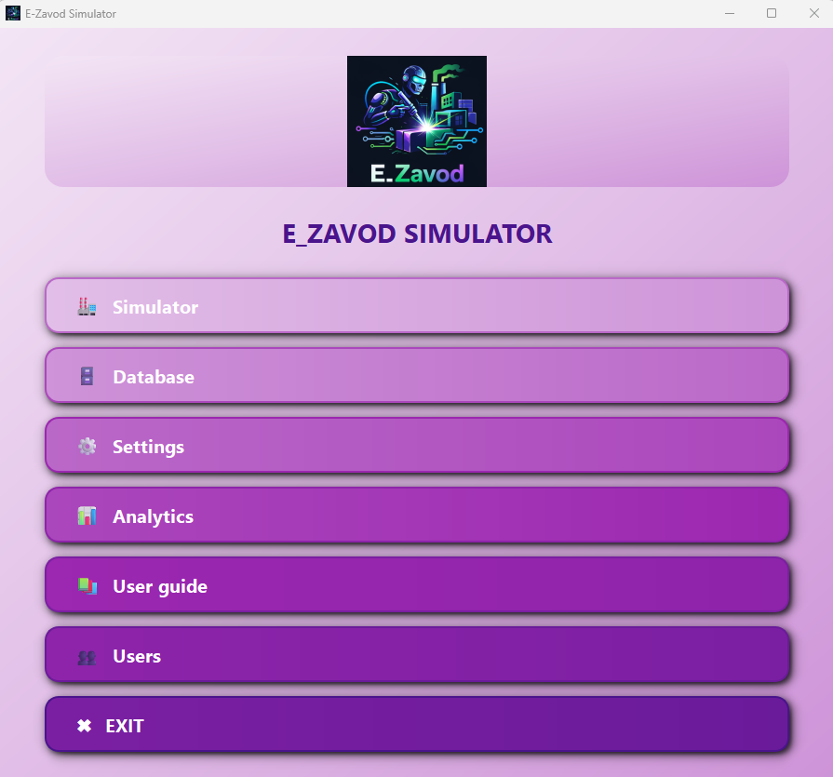
1.7
1.6
1.5
1.4
1.1
1.2
1.3
Fig. 1 Main menu
  - – Not implemented yet
  - Database menu (Partially works)
  - – Not implemented yet
  - – Not implemented yet
  - Opens the current file
  - – Not implemented yet
  - Exits the application

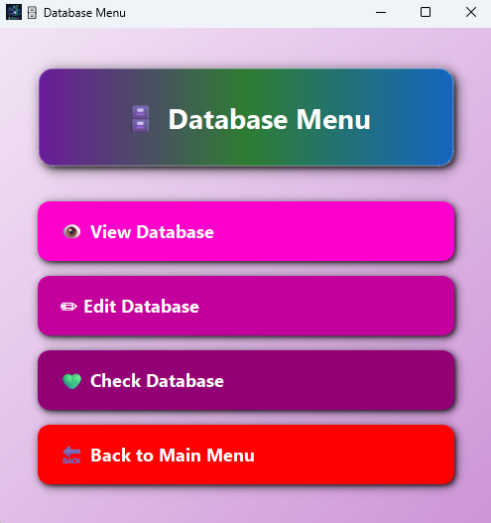
1.2 Database menu

2.1

2.2

2.3

2.4

Fig. 2 Database menu
2.1 Opens Database Viewer v 3.0
2.2 Edit database (Not implemented yet)
2.3 Check database (Will check the non-original database, not implemented yet)
2.4 Closes the current window

2.1
Database Viewer

Fig. 3
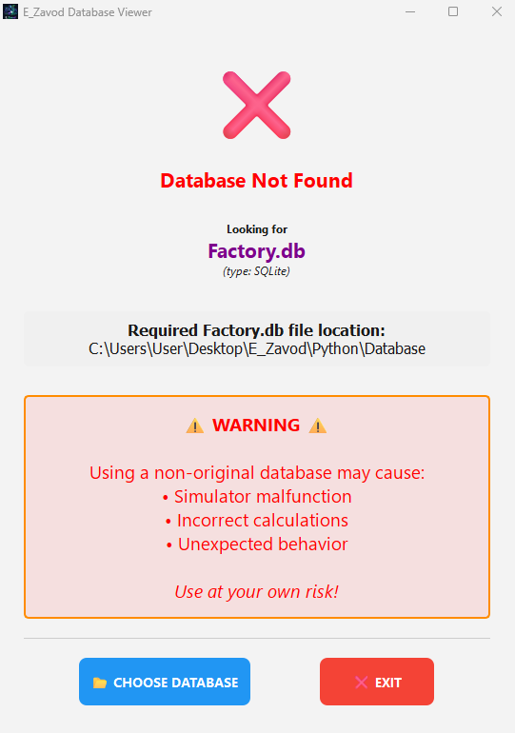
If NO database appears, such window as below will appear
Fig. 4 Database Not Found
You can either choose another database or press the EXIT button.
The required Factory.db location depends on the installation path of the simulator.
The application will remain fully available regardless.

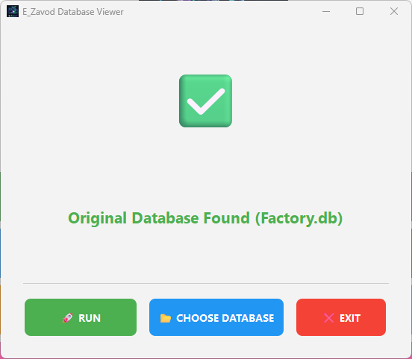
If the original database is found and available, press RUN to continue (Fig. 5)

Fig. 5 Database Found window
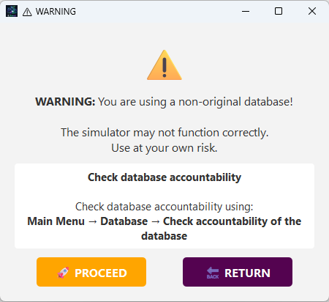
If another database needs to be viewed, such window will appear (Fig. 6)

Fig. 6 Warning Menu

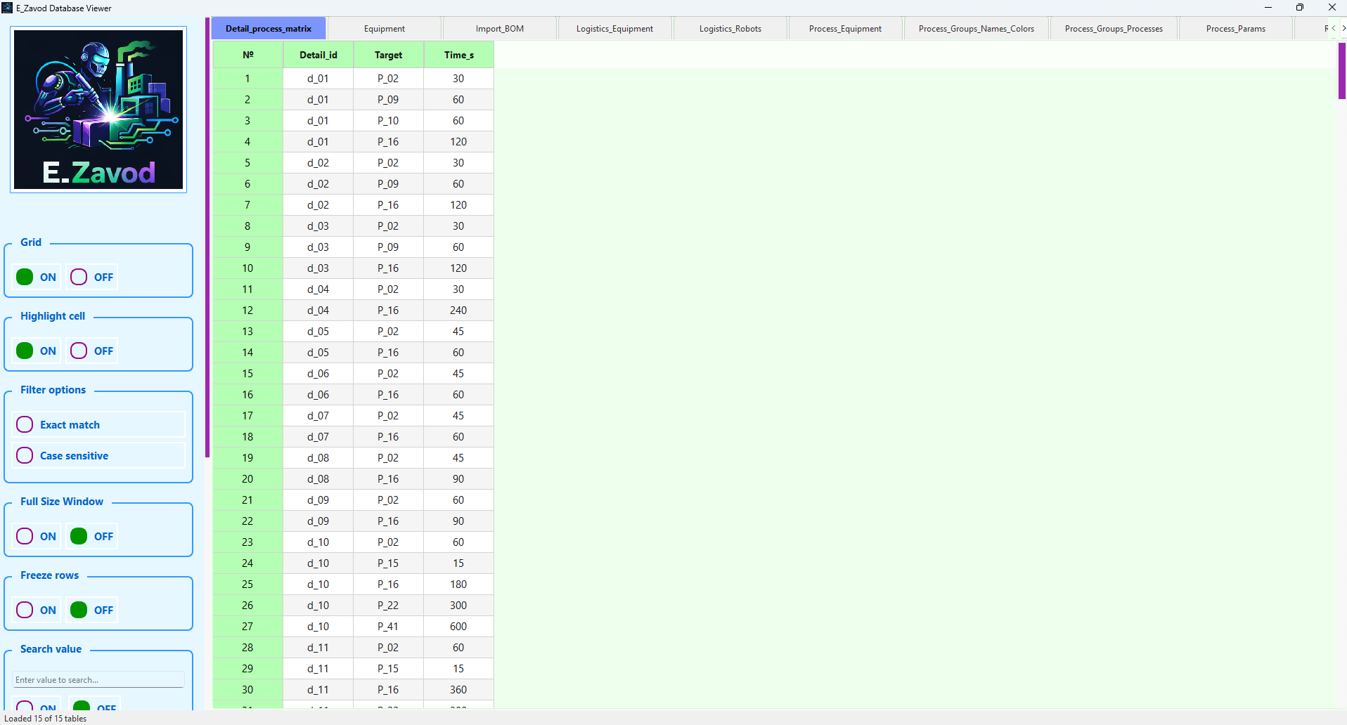
5
4
1
2
3
6
Fig. 7 Main viewer window

- current table
- table
- table tabs
- useless place
- tab switchers
- control panel
Functionality
It is possible to click on column header, and it will be highlighted. Rows cannot be highlighted in the same way. When you right‑click on a header name, an option menu (Fig. 8) will appear.
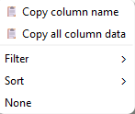

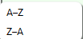

Fig. 8 Possible options
Copy column name – copies the name of the selected column.
Copy all column data – copies all cell data from the selected column. Empty cells are omitted.
Filter: by choosing Filter, only one option is available: Custom value … (Fig. 9)
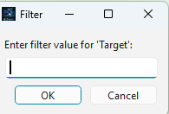
Fig. 9 Custom value… menu

Enter a value and click "OK." Only the cells that match your criteria will be displayed; all other rows will be temporarily hidden. To find out if filters were enabled, at control menu such text as below will appear (Fig. 10):
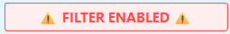
Fig. 10 Filter enabled warning
A filter symbol appears in any column where a filter is applied.
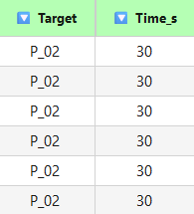
Fig. 11 Filtered columns
Two additional filter options (Fig. 12) are available in the Control Menu:
- Exact match – Displays only values that exactly match the user's input.
- Case sensitive – Distinguishes between uppercase and lowercase letters.
Both options can be used simultaneously.

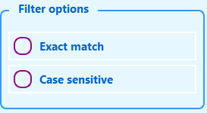
Fig. 12 Filter options
Sort: there are two options available to sort columns: from A to Z (ascending order) and from Z to A (descending order). You can only sort one column at the same time. Visual indicators show whether a sort has been applied to a column. See Figures 13.1 and 13.2 below.

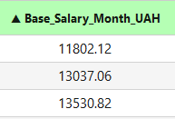
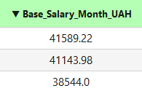

Fig. 13.1 Filter Z-A Fig. 13.2 Filter A-Z
It’s impossible to sort more than one column at a time. To reset sort press “None” (see Fig. 8), reset everything (see Fig 23 and Fig. 24) or Reset button in the control menu (See Fig. 17).
Filters and sorting can be used simultaneously. See the example below (Fig. 14)
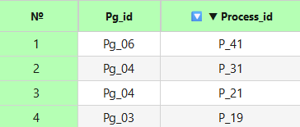
Fig. 14 Enabled filter and sort
To sort or filter a column in another table, you must first reset any existing sorts or filters. Column widths can be changed, but row heights cannot.

Tabs
Tables are displayed in tabs, with each tab name matching the corresponding database table name. The following actions are available:
- Reorder tabs by clicking and swiping any tab in any place.
- Right-click on a tab to access additional options (Fig. 15)

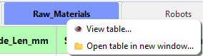
Fig. 15 Possible options

- Select View Table to open the window shown in Figure 16.
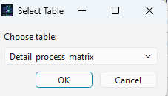
Fig. 16 Table selection

This opens the selected table in the current window. You can also use the switchers (Fig. 7, № 5) to navigate between tables.

- Open Table in New Window displays the Select Table menu (see Figure 16). When you select a table, it opens in a new, independent window (see Figure 22) with a selected table.

Control menu
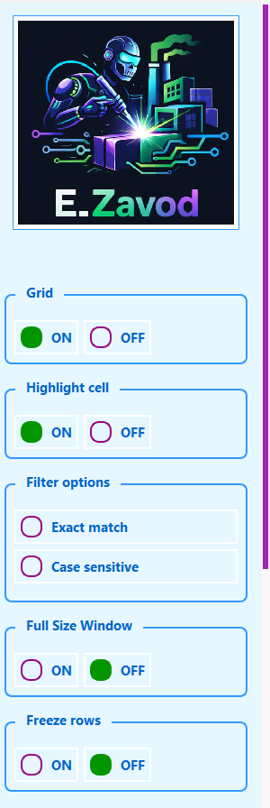
The control menu has all the functionality of the Viewer. No options from Main Menu are applicable.
1

2

3

4

5

6

7

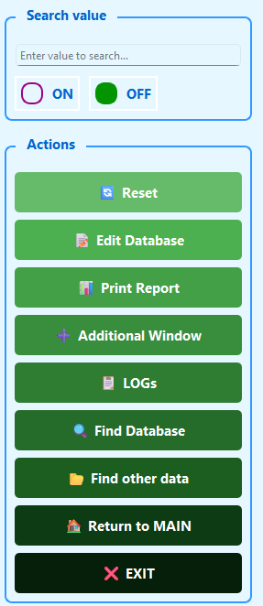
8
9

108

11

12

13
14
Fig. 17 Database Control Menu

15

- Grid – Shows or hides the grid lines.
- Highlight cell – When OFF, the row and column of the selected cell are not highlighted.
- Filter options – Enables additional filtering options (see Fig. 12).
- Full Size Window – Expands the window to full screen, hiding menus, tabs, and other interface elements. All enabled features remain available. To exit, click Close (see Figure 18). Right-click actions, sorting, filtering, and other options are still accessible.
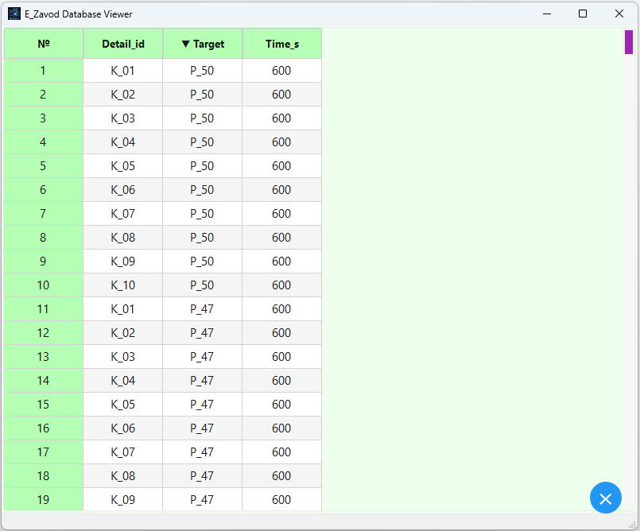
Close
Fig. 18

- Freeze rows. Double-click a row number to move it to the top of the table. The row is removed from its original position and highlighted with a background color (see Figure 19). Sorting or filtering a column automatically disables Freeze Rows. Click None (see Figure 8) to return all frozen rows to their original positions while keeping the Freeze Rows feature ON.
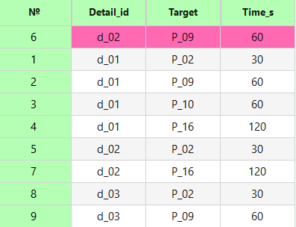
Fig. 19 Freezed rows

- Search value - Searches for a specific value across all tables. Enter the value in the text field and click ON to begin the search. You can also use the keyboard shortcut Ctrl+F to activate this feature.
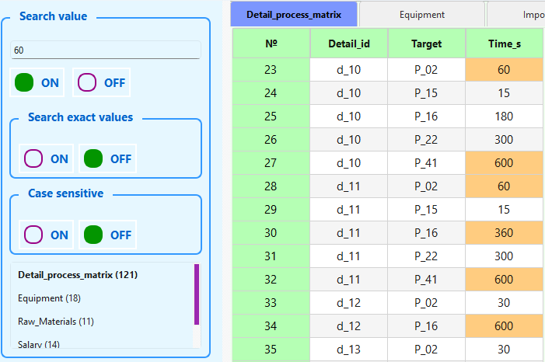
searched value
Fig. 20 Search values
Each matching value is highlighted in orange. To search only for exact matches, select Search exact value in the Search Value block of the Control Menu. The same applies to Case sensitive. The table below shows how many matches were found in each database table. The current table is always listed first. Click any row containing a table name to open that table in an additional window (see Figure 22). Matching values will be highlighted. Opening another tab does not reset the search.
- Reset - Resets all enabled options but does not close any additional windows. You can also reset by right-clicking anywhere inside a table and selecting 🔄 Reset everything.
- Edit database. Not implemented yet.
- Print Report - will show a completely new window (Fig. 21). The main window is the preview window (1). The content can be copied, and something can be added into the table. However, no value changes will be saved in the database. It loads the database (2) which can be checked (3). In the Rows block (4), it is possible to choose how many rows, except titles, should be printed. Put only an integer number in this field (beginning with 1) or choose Max so every row will be visible in the report. To separate tables, choose one of the available options in the Table separator (5). More view options are available in the Report content block (6). Themes can be changed in the Theme block (7). After every single change, press the UPDATE button! (8). There are three ways to save the report: as .pdf, as .csv, and as .txt.
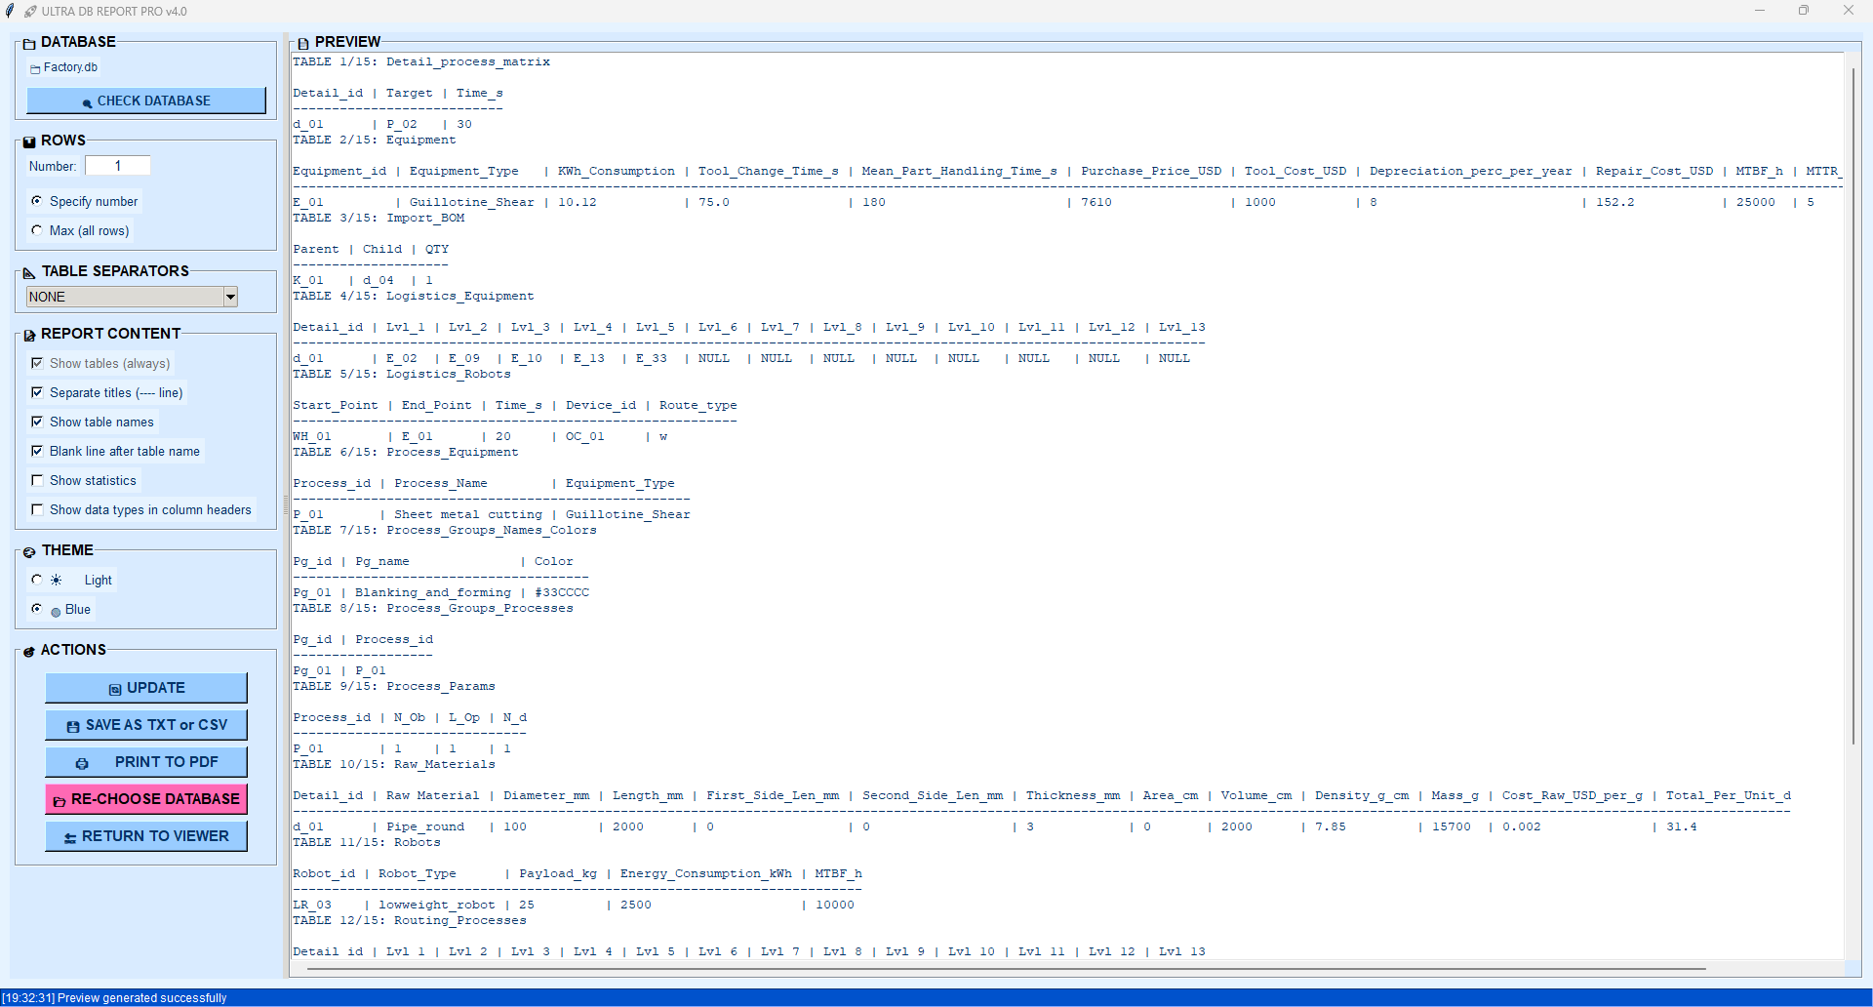
2
3
9
8
7
6
5
4
1
Fig. 21. Ultra DB Report

- Additional window - will open a new window with the saved options and the current table (see Fig. 22). The user can open as many windows as desired. Tabs are replaced with a combo box to make it easier to open the required table. Filters and sorting will be available. Searched values from the main viewer will be highlighted. There are two buttons: Close window and Reset settings. The first one will close the current window. The second one will restore only the current table from filters, sorting, and searching values.
- Logs - will open a new window with information about when the application was run. Errors will also be visible.
- Find database - provides the ability to search for a database if problems occur when opening one.
- Find other data - opens engineering data files (drawings, models, etc.).
- Return to MAIN - returns to the main menu of the simulator.
- EXIT - will close the application.
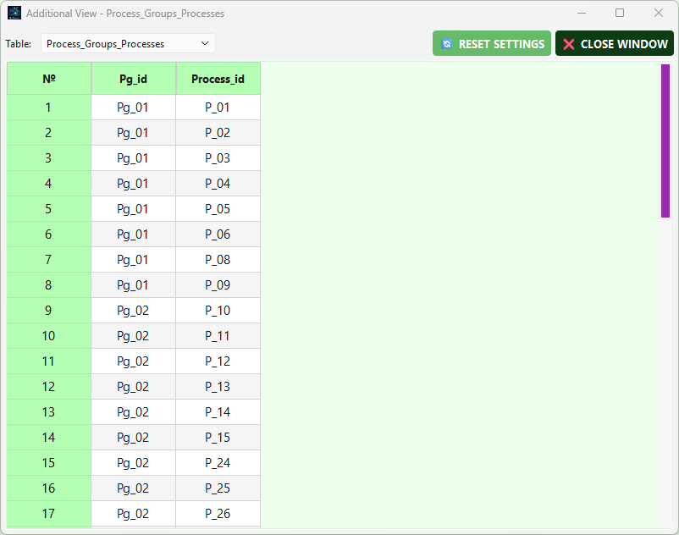
Fig. 22 Additional window
Right-Click Functionality
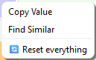
Fig. 23 Available functions
Fig. 24 Reset button
Cell’s options (Fig. 23)
- Copy Value – copies the value so it can be pasted wherever the user wants.
- Find Similar – pastes the value into the search block. This can also be done using Ctrl+F.
- Reset everything – same as shown in Fig. 24 but it shows the available option by pressing the mouse button anywhere in the window except tabs and the Control Menu.

